**Python Installation and creating Virtual Environment in Windows**

1.Install Python 3.6

2. If Python in installed Pip is comes in handby.

3.To check Python .

Enter Python in Command Prompt.

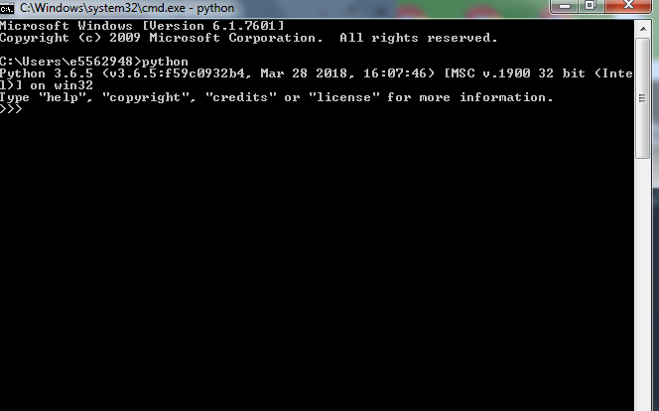

Verify your python installation

>Python –version in cmd

C:\Users\e5562948>python --version

Python 3.6.5

Verify PIP version

C:\Users\e5562948>pip --version

pip 9.0.3 from c:\program files (x86)\python36-3 2\lib\site-packages (python 3.6)

To check the pip Library list

>pip list

(or)

>pip freeze

F:\>pip list

Package Version

------------------- -------

setuptools 40.3.0

pip 18.0

Creating Virtual Environment in Windows

1.Install Virtualenv using

C:\Users\e5562948>pip install virtualenv

2.To set the Virtual Environment name

C:\Users\e5562948>virtualenv myenv

This command will create a virtualenv in the directory.

3.Check the directory whether virtualenv was created or not

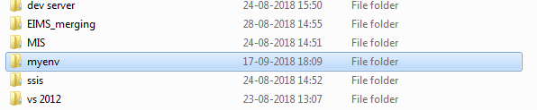

4.Command to activate the Virtualenv

F:\>cd myenv

F:\myenv>cd scripts

F:\myenv\Scripts>activate

5.PIP library Installation

>pip install Django

List of Libraries to install

* antiorm    1.2.1
* bitarray     0.8.3
* DateTime  4.2
* db     0.1.1
* db-sqlite3  0.0.1
* Django  1.11.15
* django-cors-headers 2.4.0
* djangorestframework 3.8.2
* fpdf          1.7.2
* future    0.16.0
* impyla   0.14.1
* lxml      4.2.4
* numpy     1.15.0
* pandas      0.23.4
* pip      18.0
* PyHive    0.6.0
* pyodbc     4.0.23
* pypyodbc  1.3.0
* python-dateutil     2.7.3
* pytz      2018.5
* setuptools     40.0.0
* simplejson    3.16.0
* six       1.11.0
* syspath    1.1.0
* thrift     0.11.0
* wheel       0.31.1
* XlsxWriter       1.0.5
* zope.interface   4.5.0

Host API :ss

(myenv) F:\odsapiqa>python manage.py runserver 0:7811

Performing system checks...

System check identified no issues (0 silenced).

You have 1 unapplied migration(s). Your project may not work properly until you

apply the migrations for app(s): admin.

Run 'python manage.py migrate' to apply them.

September 18, 2018 - 13:17:09

Django version 2.1.1, using settings 'odsapi.settings'

Starting development server at http://0:7811/

Quit the server with CTRL-BREAK.